Python Pillow - Flip and Rotate Images

While working on images using python image processing library, there are instances where you need to flip an existing image to get some more insights out of it, to enhance its visibility or because of your requirement.

Image module of the pillow library allows us to flip an image very easily. We are going to use the transpose (method) function from the Image module for flipping the images. Some of the mostly commonly used methods supported by ‘transpose()’ are −

* **Image.FLIP_LEFT_RIGHT** − For flipping the image horizontally
* **Image.FLIP_TOP_BOTTOM** − For flipping the image vertically
* **Image.ROTATE_90** − For rotating the image by specifying degree

Example 1: Horizontally flipped Image

Following Python example reads an image, flips it horizontally, and displays the original and flipped image using standard PNG display utility −

# import required image module

from PIL import Image

# Open an already existing image

imageObject = Image.open("images/spiderman.jpg")

# Do a flip of left and right

hori_flippedImage = imageObject.transpose(Image.FLIP_LEFT_RIGHT)

# Show the original image

imageObject.show()

# Show the horizontal flipped image

hori_flippedImage.show()

Output

**Original image**

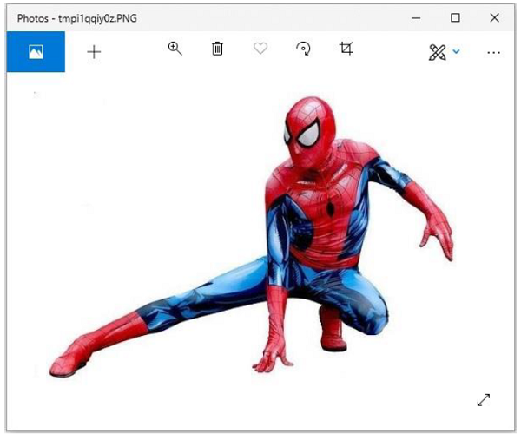

**Flipped image**

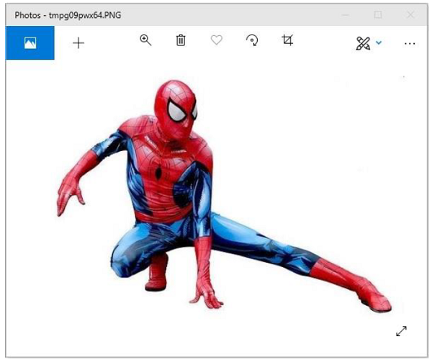

Example 2: Vertically Flipped Image

Following Python example reads an image, flips it vertically, and displays the original and flipped image using standard PNG display utility −

# import required image module

from PIL import Image

# Open an already existing image

imageObject = Image.open("images/spiderman.jpg")

# Do a flip of left and right

hori_flippedImage = imageObject.transpose(Image.FLIP_LEFT_RIGHT)

# Show the original image

imageObject.show()

# Show vertically flipped image

Vert_flippedImage = imageObject.transpose(Image.FLIP_TOP_BOTTOM)

Vert_flippedImage.show()

Output

**Original Image**



**Flipped Image**

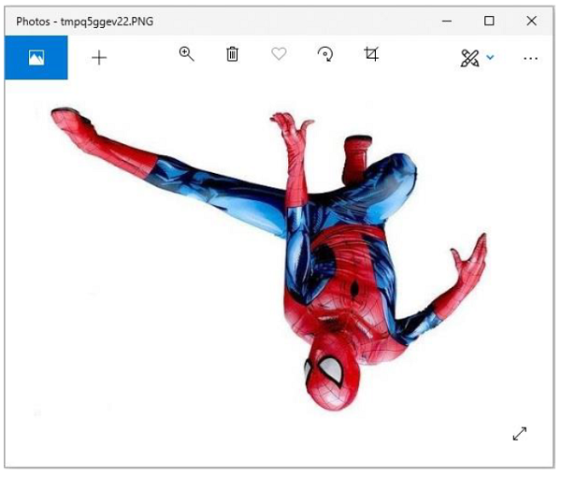

Example 3: Rotate Image to a specific degree

Following Python example reads an image, rotates to a specified degree, and displays the original and rotated image using standard PNG display utility −

# import required image module

from PIL import Image

# Open an already existing image

imageObject = Image.open("images/spiderman.jpg")

# Do a flip of left and right

hori_flippedImage = imageObject.transpose(Image.FLIP_LEFT_RIGHT)

# Show the original image

imageObject.show()

#show 90 degree flipped image

degree_flippedImage = imageObject.transpose(Image.ROTATE_90)

degree_flippedImage.show()

Output

**Original Image**



**Rotated Image**

